SUSTAINABLE FOOD WASTE REDUCTION PLATFORM
A CASE STUDY REPORT
Submitted in the partial fulfilment for the Course of
CSA1008– SOFTWARE ENGINEERING
to the award of the degree of

BACHELOR OF TECHNOLOGY IN
ARTIFICIAL INTELLIGENCE AND DATA SCIENCE
Submitted by
MAHALAKSHMI S (192524372)

Under the Supervision of
Dr. SHARMILI K



SIMATS ENGINEERING
Saveetha Institute of Medical and Technical Sciences
Chennai – 602105
JULY 2026

TABLE OF CONTENTS

S. No | Topic | Page No.
1 | INTRODUCTION | 6
2 | PROBLEM UNDERSTANDING | 7
3 | STAKEHOLDER ANALYSIS | 10
4 | EXISTING SYSTEM ANALYSIS | 13
5 | PROPOSED SOFTWARE SOLUTION | 16
6 | SYSTEM DESIGN | 19
7 | METHODOLOGY/SDLC SELECTION | 22
8 | IMPLEMENTATION PLAN | 24
9 | EXPECTED OUTCOMES
10 | RISK AND LIMITATIONS
11 | FUTURE ENHANCEMENT
12 | CONCLUSION
13 | REFERENCE
14 | APPENDIX

1. INTRODUCTION

1.1 Background of the Problem
Food waste is a significant global issue affecting economic, social, and environmental sustainability. Restaurants, supermarkets, hotels, and event organizers often generate large quantities of surplus food that remain safe and suitable for consumption. However, due to the lack of an effective redistribution mechanism, much of this food is discarded. At the same time, charities and community organizations struggle to provide sufficient food to vulnerable populations.
The absence of a centralized communication and coordination system between food donors and charities results in inefficient food distribution. Consequently, valuable resources are wasted while many individuals continue to experience food insecurity. A software-based platform can bridge this gap by facilitating timely communication, donation management, and food redistribution.

1.2 Importance of Solving the Problem
Reducing food waste offers multiple benefits, including environmental protection, resource conservation, and improved food security. By redirecting surplus food to charitable organizations, communities can reduce landfill waste, lower greenhouse gas emissions, and support vulnerable populations.

1.3 Related SDG Goals
- SDG 12 – Responsible Consumption and Production
- SDG 2 – Zero Hunger
- SDG 11 – Sustainable Cities and Communities

Objectives of the Case Study
- Analyze the food waste management problem.
- Design a software-based food redistribution platform.
- Reduce food wastage.
- Increase transparency and accountability.

2. PROBLEM UNDERSTANDING

2.1 Problem Description
Many restaurants, supermarkets, and event organizers generate surplus food daily. Due to the lack of a centralized platform, this food is often discarded despite being suitable for consumption. Charitable organizations willing to collect and distribute the food frequently lack information regarding available donations. This results in increased food waste and continued hunger among disadvantaged communities.
The challenge is to create a software solution that efficiently connects food donors with charities, enabling quick identification, allocation, and collection of surplus food.

2.2 Objectives
- Reduce food wastage.
- Simplify food donation processes.
- Improve coordination between donors and charities.
- Provide real-time notifications.
- Increase transparency and accountability.

2.3 Scope

In Scope
- Donor registration
- Charity registration
- Login and authentication
- Food donation listing
- Donation requests
- Notification services

Out of Scope
- Food quality testing
- Transportation management
- Financial transactions
- Online food sales

3. STAKEHOLDER ANALYSIS
Stakeholder | Role | Responsibilities | Challenges
Administrator | System Manager | Manage users, monitor donations, generate reports, maintain system operations. | Maintaining security and handling large amounts of data.
Food Donor | Food Provider | Upload food donation details and coordinate collection. | Timely updates and donation scheduling.
Charity Organization | Food Receiver | Request available donations and distribute food. | Transportation and collection logistics.
Volunteers | Support Staff | Assist with food collection and delivery. | Availability and scheduling.
Government Agencies | Regulators | Monitor compliance and food safety regulations. | Policy enforcement.
System Developers | Technical Team | Develop and maintain the platform. | Scalability and maintenance.
Beneficiaries | End Users | Receive redistributed food. | Accessibility and availability.

4. EXISTING SYSTEM ANALYSIS

4.1 Existing Process
Currently, food donation activities are coordinated through phone calls, emails, social media platforms, and personal networks. Donors manually contact charities to arrange pickups. The process is time-consuming and lacks systematic tracking.

4.2 Strengths
- Simple communication methods.
- No specialized software required.
- Low initial investment.
- Existing charity networks available.

4.3 Weaknesses
- Lack of real-time updates.
- Poor coordination.
- No centralized database.
- Limited transparency.
- High risk of food wastage.
- Difficult tracking and reporting.

4.4 Gap Analysis
The current system fails to:
- Match donors and charities efficiently.
- Track donations systematically.
- Generate reports.
- Provide instant notifications.
- Ensure accountability and transparency.

5. PROPOSED SOFTWARE SOLUTION

5.1 Proposed System
The proposed Sustainable Food Waste Reduction Platform is a web and mobile-based application that connects food donors with registered charities. Donors can upload surplus food information, while charities can browse available donations and request collections. The system provides notifications, scheduling, reporting, and monitoring features.

5.2 Functional Modules
- User Registration
- Login and Authentication
- Donor Dashboard

5.3 Functional Requirements
ID | Functional Requirement
FR1 | The system shall allow donors to register.
FR2 | The system shall allow charities to register.
FR3 | The system shall authenticate users securely.
FR4 | The system shall allow donors to create food listings.
FR5 | The system shall display available food donations.
FR6 | The system shall allow charities to request donations.
FR7 | The system shall send real-time notifications.
FR8 | The system shall schedule food pickups.
FR9 | The system shall generate reports.
FR10 | The administrator shall manage users and donations.

5.4 Non-Functional Requirements
Category | Requirement
Performance | Response time should be less than 3 seconds.
Security | User data shall be encrypted.
Scalability | The platform shall support increasing users.
Reliability | The system shall maintain 99% uptime.
Maintainability | Code shall be modular and documented.
Availability | The system shall be accessible 24/7.
Usability | User interfaces shall be intuitive.
Portability | The application shall work across devices and operating systems.

5.5 Software Engineering Principles Applied
- Modularity: Separate modules for donations, users, notifications, and reports.
- Scalability: Cloud-ready architecture.
- Reliability: Backup and recovery mechanisms.
- Security: Authentication and access control.
- Maintainability: Standardized coding practices.

6. SYSTEM DESIGN

6.1 Use Case Diagram
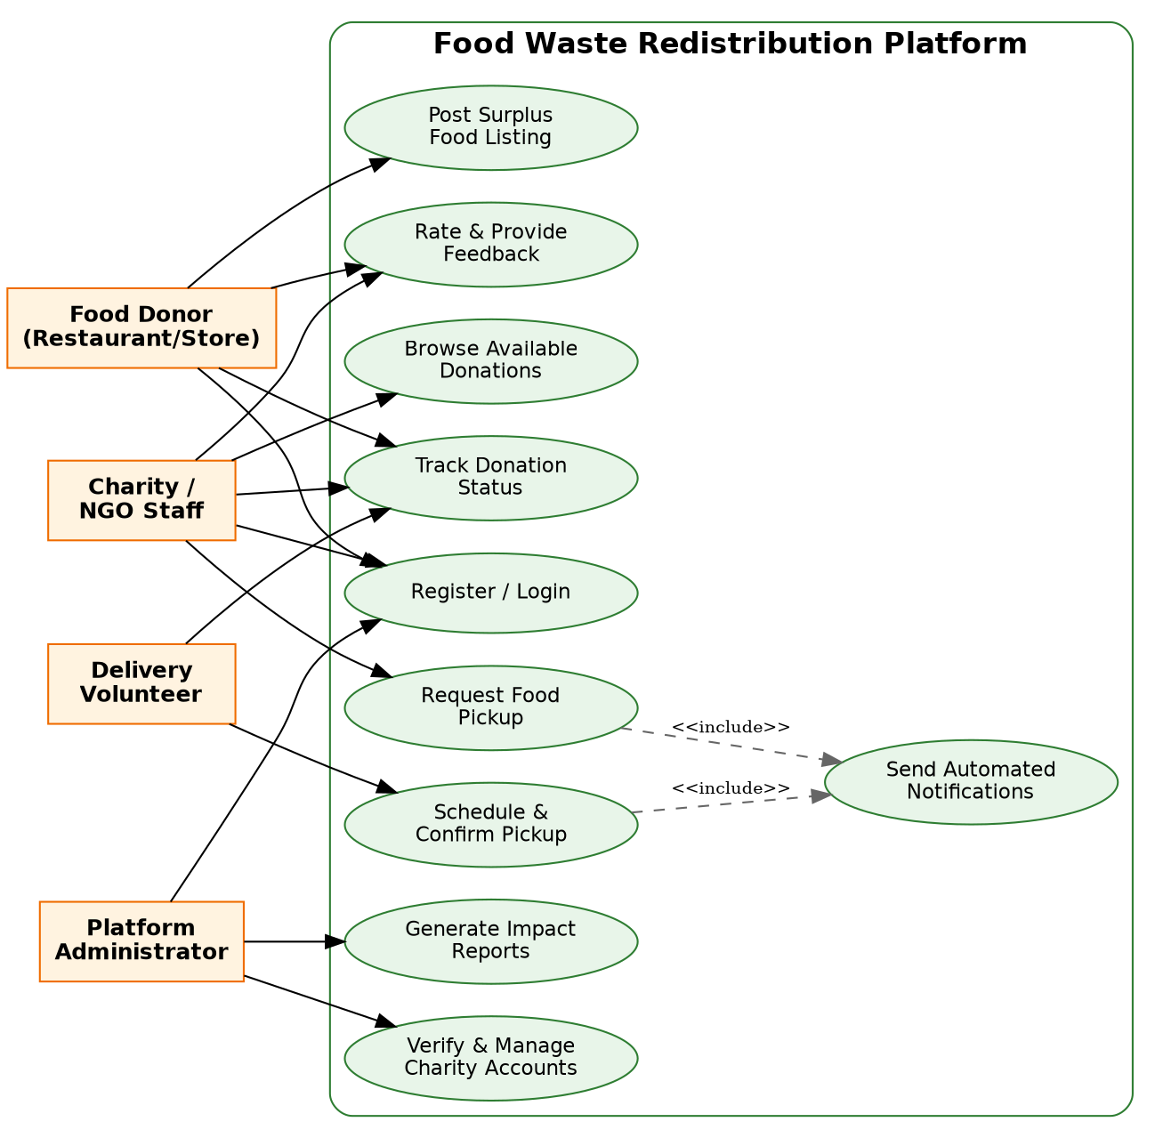

6.2 Activity Diagram

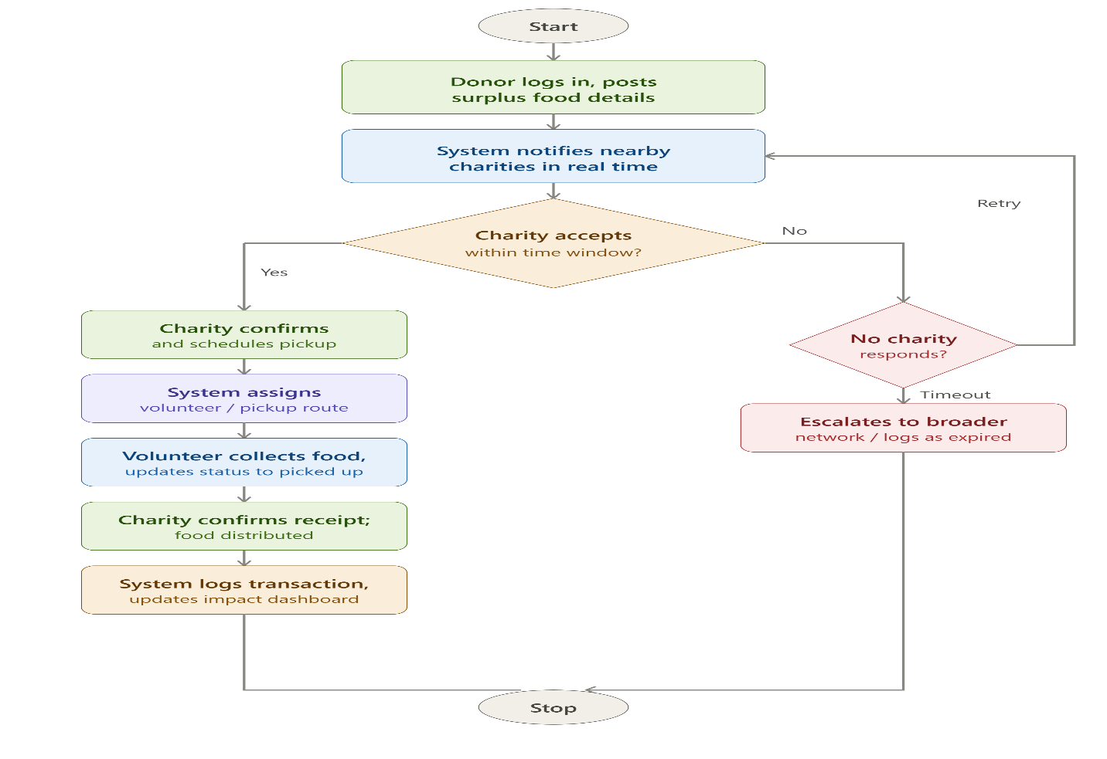

6.3 WORKFLOW DIAGRAM
Figure 3: Workflow Diagram

6.4 System Architecture Diagram
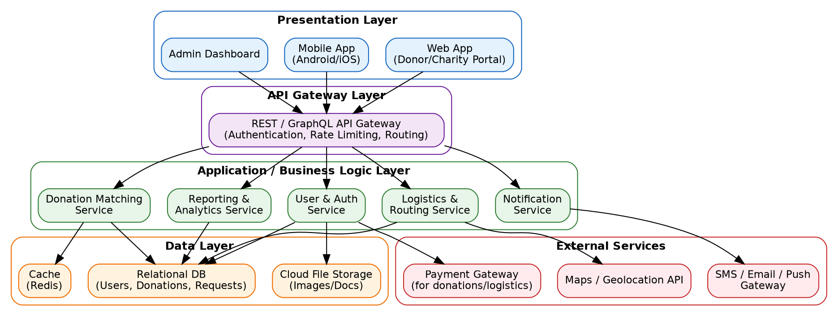
Figure 4: System Architecture Diagram

6.5 Database ER Diagram
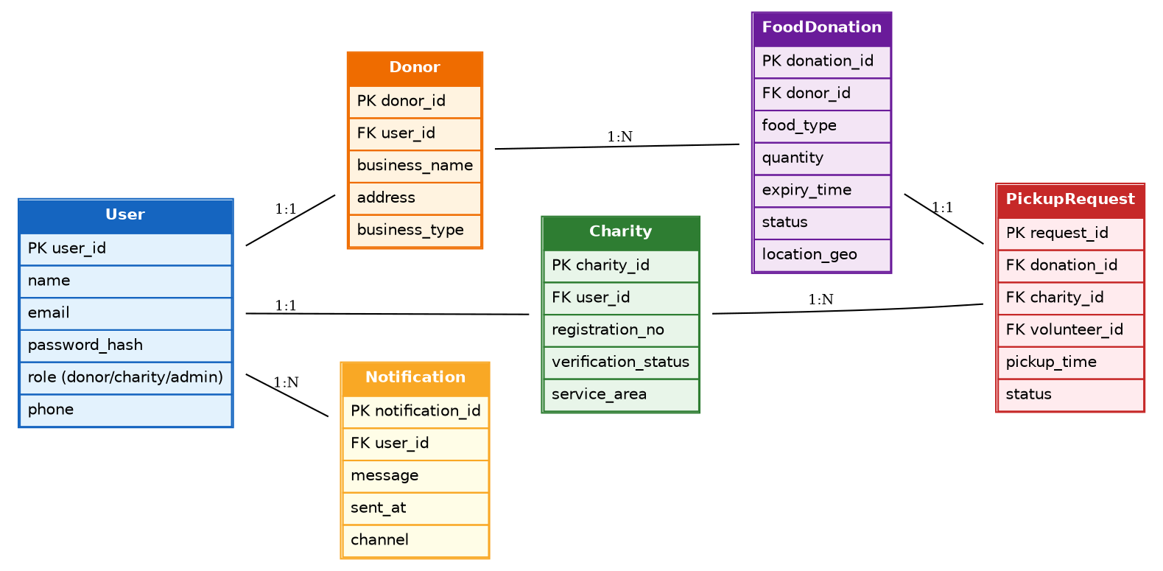
Figure 5: Database ER Diagram

6.6 Flowchart
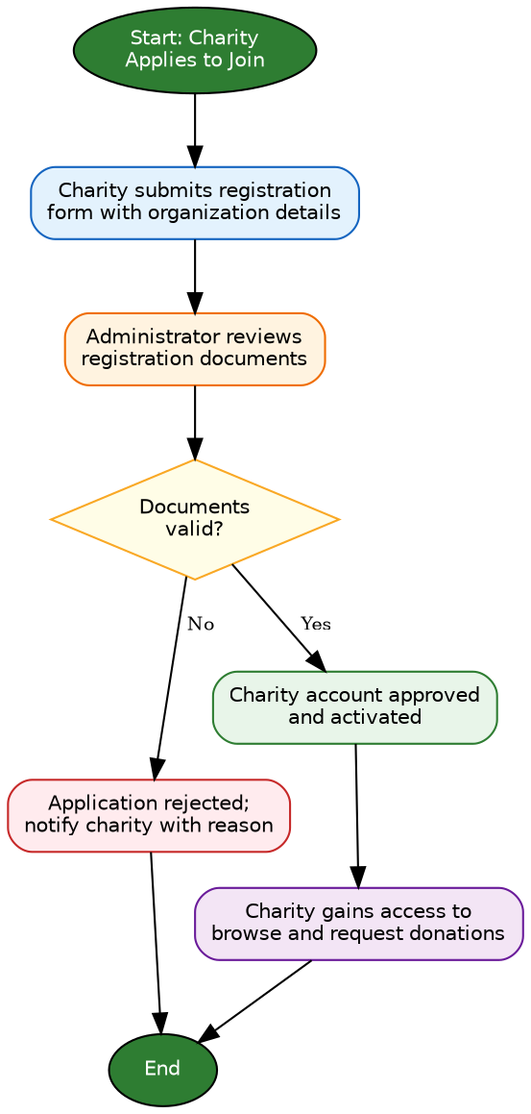
Figure 6: Flowchart — Charity Verification Process

6.7 Wireframe Screens
LOGIN PAGE

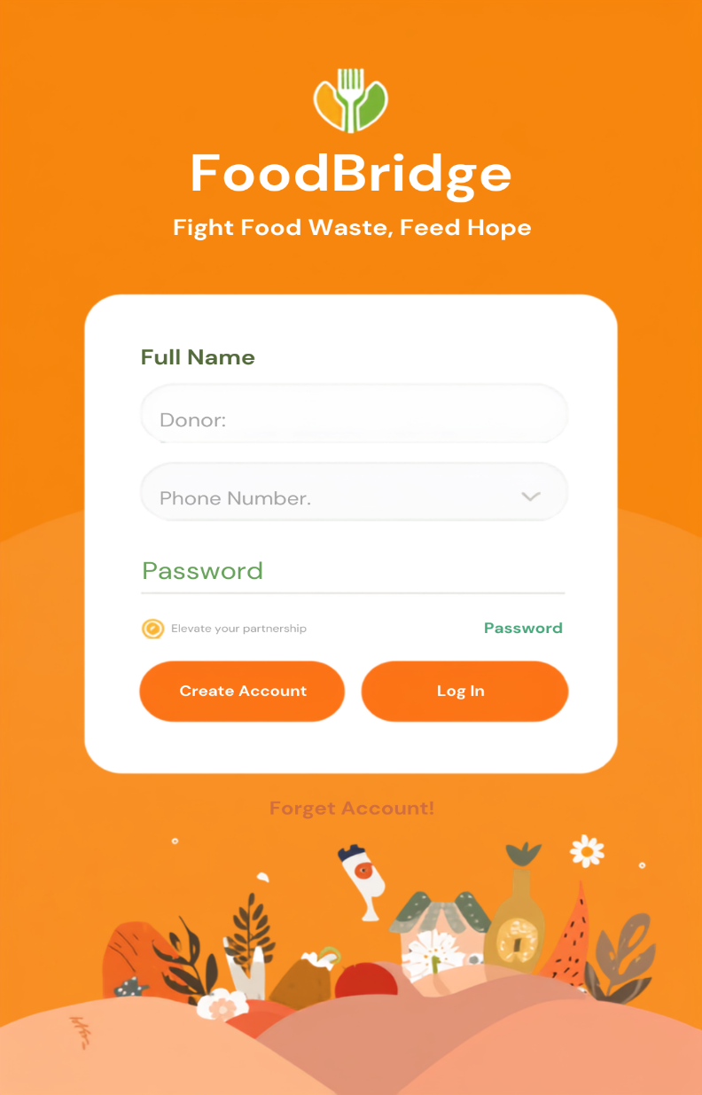

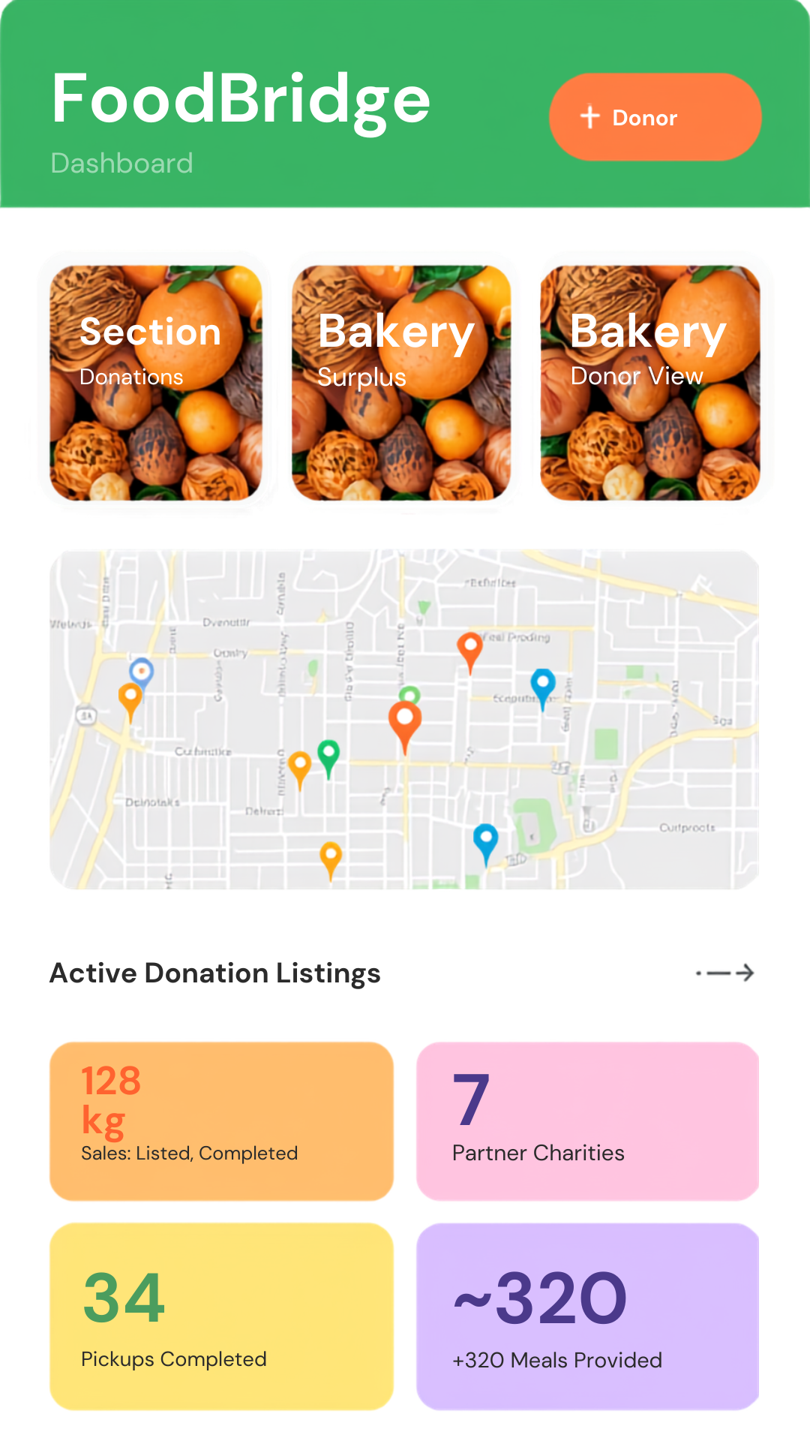

DASHBOARD

7. METHODOLOGY / SDLC SELECTION

7.1 Selected Model: Agile Scrum

Why Agile Scrum?
The Sustainable Food Waste Reduction Platform involves multiple stakeholders, including food donors, charities, volunteers, and administrators. Since the requirements of these stakeholders may evolve during development, an Agile Scrum methodology is selected. Agile allows the development team to work in short iterations called sprints and continuously improve the system based on stakeholder feedback.

Advantages of Agile Scrum
- Faster delivery of software features.
- Improved communication among stakeholders.
- Continuous testing and quality assurance.
- Easy adaptation to changing requirements.

Suitability for the Proposed System
Agile Scrum is highly suitable for the proposed food redistribution platform because the system may require modifications based on user experiences and operational challenges.

7.2 Development Stages

Requirement Gathering.

Sprint Planning

System Design

Development

Testing

Sprint Review

Deployment

Maintenance

8. IMPLEMENTATION PLAN
Phase | Duration
Requirement Gathering | 1 Week
System Design | 1 Week
Development | 3 Weeks
Testing | 1 Week
Deployment | 1 Week
Maintenance | Ongoing

9. EXPECTED OUTCOMES

9.1 Benefits
The proposed platform is expected to significantly reduce food wastage by connecting food donors with charities in real time. The system provides a centralized platform where surplus food can be listed, requested, and redistributed efficiently.
Key benefits include:
- Reduction of edible food waste.
- Improved food accessibility for vulnerable communities.
- Faster communication between donors and charities.
- Better utilization of available food resources.
- Increased transparency in food donation activities.

9.2 Business Impact
The platform will improve operational efficiency for nonprofit organizations and charities. Administrative tasks such as donor management, donation tracking, and report generation will become automated.
Business impacts include:
- Reduced administrative workload.
- Improved reporting accuracy.
- Better resource allocation.
- Increased organizational credibility.
- Enhanced stakeholder trust.

9.3 User Benefits

For Donors
- Simple food donation process.
- Quick listing of surplus food.
- Ability to track donation status.
- Reduced food disposal costs.

For Charities
- Easy access to available donations.
- Faster response to food availability.
- Better planning of food distribution activities.
- Improved service delivery to beneficiaries.

For Administrators
- User management tools.
- Monitoring and reporting capabilities.
- Data-driven decision making.

9.4 Social Impact
The platform contributes positively to society by reducing hunger and promoting sustainable consumption practices.
Social impacts include:
- Increased support for vulnerable populations.
- Reduced environmental pollution caused by food waste.
- Strengthened community collaboration.
- Enhanced public awareness regarding food sustainability.

9.5 Contribution to Sustainable Development Goals
The proposed solution directly supports:

SDG 12 – Responsible Consumption and Production
By reducing food waste and improving resource utilization.

SDG 2 – Zero Hunger
By ensuring surplus food reaches people facing food insecurity.

SDG 11 – Sustainable Cities and Communities
By promoting sustainable resource management and community welfare.

10. RISKS AND LIMITATIONS

10.1 Internet Dependency
The platform requires internet connectivity for accessing food listings, sending notifications, and processing requests. Poor internet connectivity may affect system performance.

10.2 Data Privacy Concerns
User information such as contact details and organizational records must be protected from unauthorized access.

10.3 Security Threats
Potential cyber threats include:
- Unauthorized access.
- Data breaches.
- Malware attacks.

10.4 Budget Constraints
Development, deployment, and maintenance costs may affect project implementation, especially for nonprofit organizations with limited funding.

10.5 User Adoption Challenges
Some donors and charities may be reluctant to adopt new technology due to limited technical knowledge or resistance to change.

10.6 Food Safety Concerns
Although the platform facilitates food redistribution, it cannot guarantee food quality after donation. Proper food handling guidelines must be followed.

10.7 Technical Challenges
Possible technical challenges include:
- System downtime.
- Server failures.
- Database issues.

11. FUTURE ENHANCEMENTS

11.1 Artificial Intelligence (AI)
AI can be used to automatically match food donations with charities based on location, food type, quantity, and urgency.
Benefits:
- Faster matching.
- Improved efficiency.

11.2 Predictive Analytics
Machine learning algorithms can analyze historical donation patterns and predict future food demand.

11.3 Chatbot Integration
An AI-powered chatbot can assist users by answering frequently asked questions and guiding them through donation procedures.

11.4 Internet of Things (IoT)
IoT sensors can monitor food storage conditions such as temperature and humidity during transportation.

11.5 Mobile Application
A dedicated Android and iOS application can improve accessibility and user engagement.

11.6 Blockchain Technology
Blockchain can provide secure and transparent tracking of food donations, improving accountability.

11.7 Cloud Deployment
Migrating the platform to cloud infrastructure can improve scalability, availability, and disaster recovery capabilities.

12. CONCLUSION
Food waste and hunger remain major social challenges worldwide. The proposed Sustainable Food Waste Reduction Platform provides a centralized and efficient solution for connecting food donors with charities. Through real-time communication, automated notifications, donation tracking, and reporting features, the platform helps reduce food waste and improve food accessibility for vulnerable populations. The proposed system contributes directly to SDG 12 while also supporting SDG 2 and SDG 11. By leveraging software engineering principles and Agile Scrum methodology, the platform can be developed as a scalable, reliable, and sustainable solution for food redistribution.

13. REFERENCES

de Almeida Oroski, Fabio, and Jessica Monteiro da Silva. "Understanding food waste-reducing platforms: A mini-review." Waste Management & Research 41.4 (2023): 816-827.

Amaral, Diego Gama, and Renato J. Orsato. "Digital platforms for food waste reduction: The value for business users." Business Strategy and the Environment 32.4 (2023): 1373-1387.

Cane, Massimo, and Carmen Parra. "Digital platforms: mapping the territory of new technologies to fight food waste." British Food Journal 122.5 (2020): 1647-1669.

Mattila, Malla, Nina Mesiranta, and Anna Heikkinen. "Platform-based sustainable business models: reducing food waste in food services." International Journal of Entrepreneurship and Innovation Management 24.4-5 (2020): 249-265.

Du, Wanqi, et al. "The effects of an online food waste reduction platform in university canteens in Wuhan, China." Journal of Cleaner Production 468 (2024): 142991.

14. Appendix
Donor Survey: Sample questions to understand how often businesses generate surplus food, their willingness to use the app, and what would encourage regular donations.
Charity Survey: Sample questions to understand how charities currently find donations, their capacity, and what information/verification they'd need before accepting food.
Food Safety Checklist: A self-declaration checklist donors must confirm (hygienic preparation, not previously served, safe temperature, accurate timing, photo upload) before posting a listing.
Sample Donation Form Fields: Key data captured per listing — food type, quantity, prepared time, pickup window, location, storage condition, photo, and special notes.
Additional Items: Space reserved for user feedback forms, extra diagrams, UI screenshots, impact reports, and testing results collected during pilot implementation.

